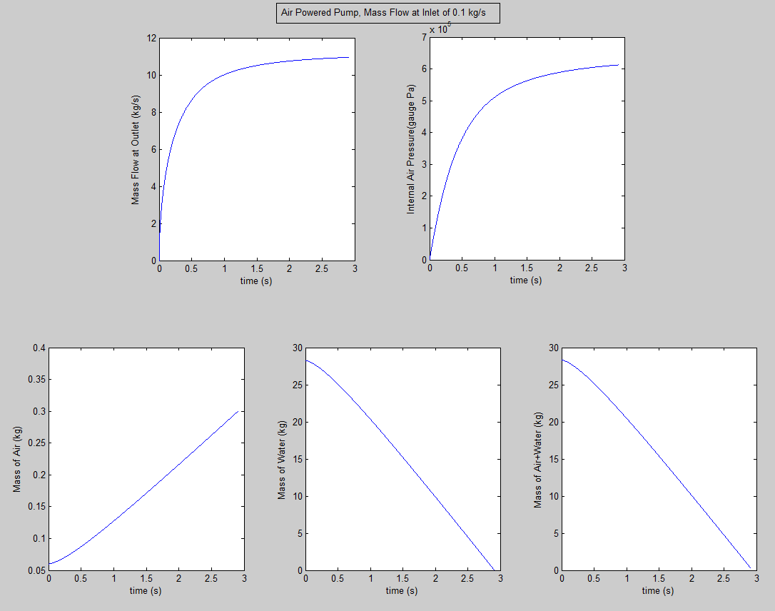

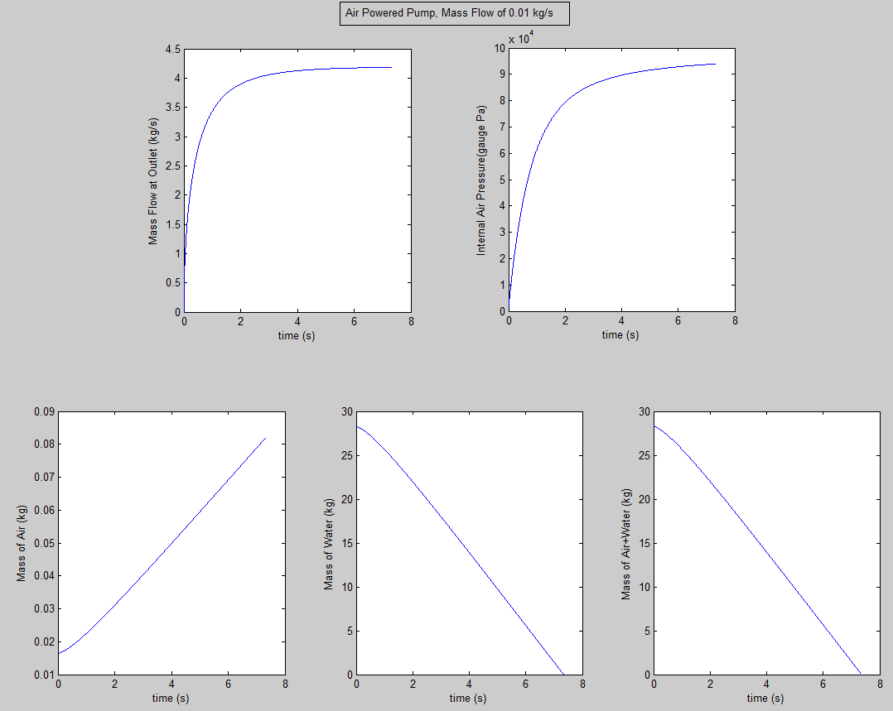

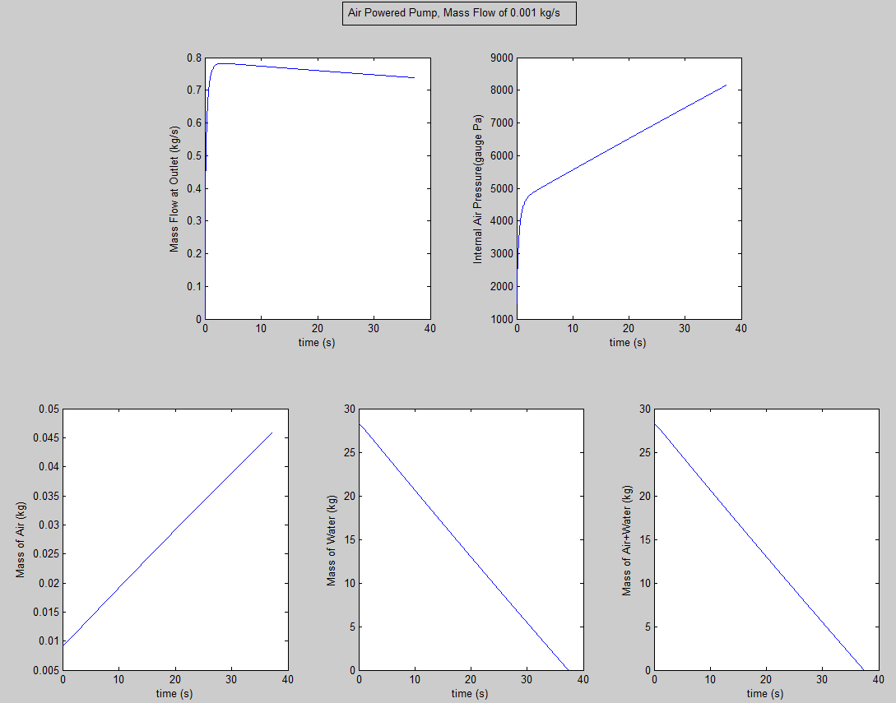

Figures 1, 2, and 3: Rate of mass flow at outlet, internal air pressure, and mass of air and/or water as functions of time at various inlet mass flow rates.

Appendix A: MATLAB Code

%Short program to simulate conditions in air powered water pump

%Josh Bevan Sept 2013

%22.581 HW#1, Problem 4

clc

%Physical constants

g =9.8; %m/s^2

rhoL =1000; %kg/m^3

PAtm =101325; %Pa

R =287.058; %J/kg K

c_air =340; %m/s

%Problem ICs

% | A

% ___|___ | H1

% | H3 | V

% |=====| A

% | | | H2

% |_____| V

T =293; %K

H1_0 =0.15; %m

H2_0 =0.4;

H3_0 =0.1;

D1 =0.3; %m

D2 =0.02;

D3 =0.02;

mDotL_0 =0; %kg/s Flow of water through exit

P0 =g* rhoL* H1_0 + PAtm; %Pressure of air in pump

%Inputs

mDotA =0.001; %kg/s Flow of air into pumped port________________________________Modify Here

del_t =0.001; %s Timestep for iterative time marching

max_t =40; %s Maximum time to simulate for

steps =floor(max_t/del_t +1);

%Functions defined:

%[mDotL] = Calc_mDotL(PAir, H1, rhoL, PAtm, D3, g)

%[PDot] = Calc_PDot(PAir, H3, mDotL, mDotA, rhoL, D1, R, T)

%[p1,p2,p3,p4,p5] = PlotResults(time, data, D1, saved_H2, saved_H3, saved_rhoA, rhoL, saved_mDotL, saved_PAir)

%Main loop

%%Initialization

PAir =P0;

H1 =H1_0;

H2 =H2_0;

H3 =H3_0;

mDotL =mDotL_0;

%Preallocate save structures

step=1;

saved_mDotL =zeros(steps,1);

saved_H2=zeros(steps,1);

saved_H3=zeros(steps,1);

saved_PAir=zeros(steps,1);

saved_mDotL(step)=mDotL;

saved_H2(step)=H2;

saved_H3(step)=H3;

saved_PAir(step)=PAir-PAtm;

for t=0:del_t:max_t;

step =step+1;

PDot =Calc_PDot(PAir, H3, mDotL, mDotA, rhoL, D1, R, T);

mDotL =Calc_mDotL(PAir, H1, rhoL, PAtm, D3, g);

PAir =PAir + PDot*del_t; %Pa Calculate new PAir based on rate of change

if H2 %If water hasn't been exhausted

del_H2 =del_t*((-4* mDotL)/(pi* D1^2* rhoL)); %m Calculate change in water height due to water flow out

H2 = max(H2+del_H2,0);

H1 =H1-del_H2; %

H3 =H3-del_H2; %Both H1 and H3 decrease in magnitude by del_H3

%Save data

saved_mDotL(step)=mDotL;

saved_H2(step)=H2;

saved_H3(step)=H3;

saved_PAir(step)=PAir-PAtm;

saved_rhoA =PAir/(R*T);

else %Plot when empty

PlotResults(0:del_t:t,1:step-1, D1, saved_H2, saved_H3, saved_rhoA, rhoL, saved_mDotL, saved_PAir);

return

end

end

%If sim hasn't run to conclusion, plot what we have

PlotResults(0:del_t:max_t+del_t,1:steps+1, D1, saved_H2, saved_H3, saved_rhoA, rhoL, saved_mDotL, saved_PAir);

%For the purposes of printing, function files:

% function [mDotL] = Calc_mDotL(PAir, H1, rhoL, PAtm, D3, g)

% mDotL = rhoL*pi*(D3^2/4)*sqrt(2*((PAir-PAtm)/rhoL-g*H1));

% end

%

% function [PDot] = Calc_PDot(PAir, H3, mDotL, mDotA, rhoL, D1, R, T)

% PDot = (4/(pi*D1^2*H3))*(mDotA*R*T - (PAir*mDotL/rhoL));

% end

%

% function [p1,p2,p3,p4,p5] = PlotResults(time, data, D1, saved_H2, saved_H3, saved_rhoA, rhoL, saved_mDotL, saved_PAir)

% saved_mL =pi*(D1^2/4)*saved_H2*rhoL;

% saved_mA =pi*(D1^2/4)*saved_H3.*saved_rhoA;

% saved_mAL =saved_mA + saved_mL;

% p1=subplot(231);plot(time, saved_mDotL(data));xlabel('time (s)');ylabel('Mass Flow at Outlet (kg/s)');

% p2=subplot(232);plot(time, saved_PAir(data));xlabel('time (s)');ylabel('Internal Air Pressure(gauge Pa)');

% p3=subplot(234);plot(time, saved_mA(data));xlabel('time (s)');ylabel('Mass of Air (kg)');

% p4=subplot(235);plot(time, saved_mL(data));xlabel('time (s)');ylabel('Mass of Water (kg)');

% p5=subplot(236);plot(time, saved_mAL(data));xlabel('time (s)');ylabel('Mass of Air+Water (kg)');

% end